Literature research 2: network structures

For transfer learning, the following networks could be used: <https://keras.io/applications/> (resnet?)

Besides this, we could make our own version of AlexNet. AlexNet(2012) is a neural network structure used to classify ImageNet data. It consists of 5 convolutional layers and 3 convolutional layers. It also uses ReLU nodes, max pooling and dropout. This network is, however, ran on two GPU’s for training, making the model slightly more complicated.[1] A more simplified version could still prove useful for this classification problem.[2]

|  |  |  |  |  |  |  |  |  |
| --- | --- | --- | --- | --- | --- | --- | --- | --- |
| **Structure based on AlexNet [2]** | Conv1: 7: 4: 0: 120: ReLU Max Pool:3:2 LRN | Conv2: 5: 1: 2: 240: ReLU Max Pool:3:2 LRN | Conv3: 3: 1: 1: 360: ReLU | Conv4: 3: 1: 1: 360: ReLU | Conv5: 3: 1: 1: 360: ReLU Max Pool:3:2 | FC1: 500: ReLU Dropout | FC2: 300: ReLU Dropout | FC3: Softmax |

For convolutional layers, filter size, stride, padding size, number of filters, activation function are given respectively.

VGG net is also possible:

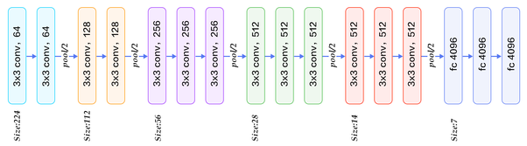

Besides these complicated networks, I suggest we also make a very simple neural network, to see the results of using a more complicated architecture.

A potential problem is that these architectures are meant to classify input with 1000 outputs, we only need 2 outputs (yes or no metastases).